**Introduction:**

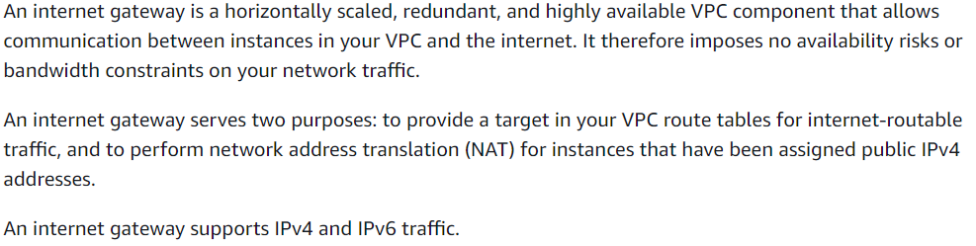

**Enabling internet access:**

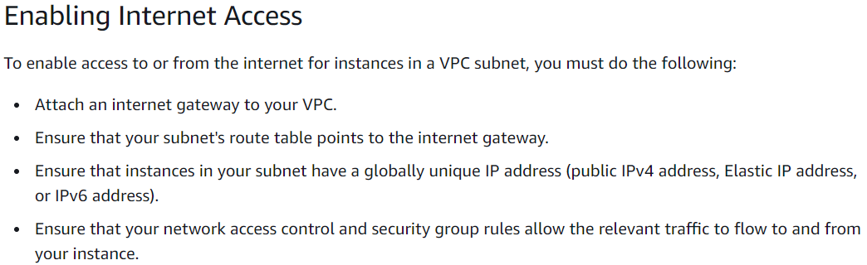

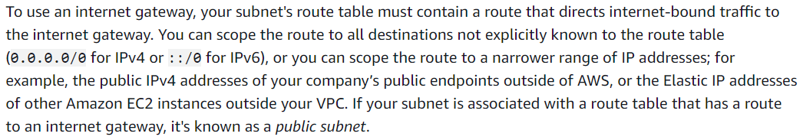

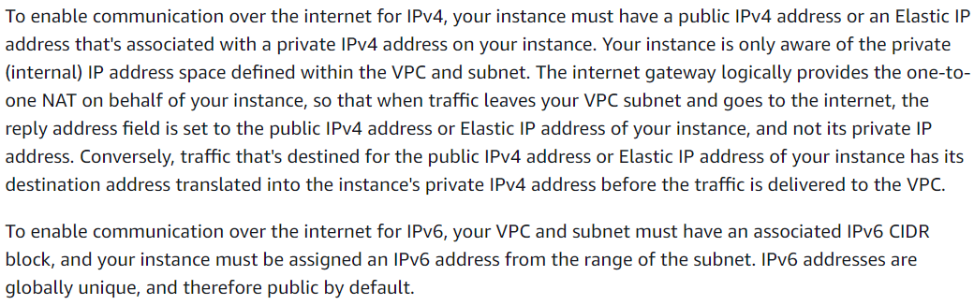

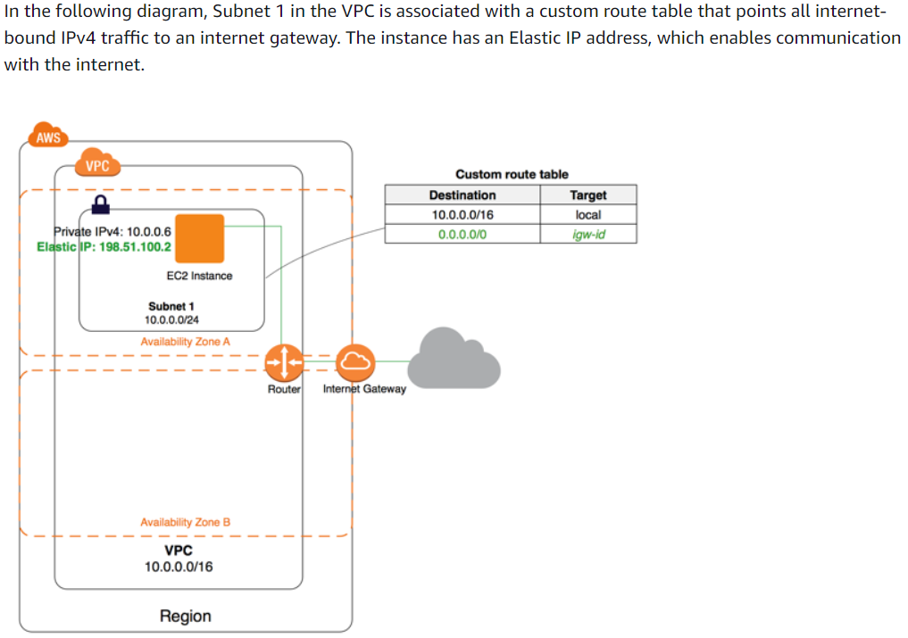

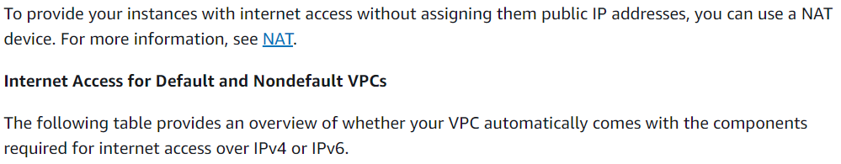

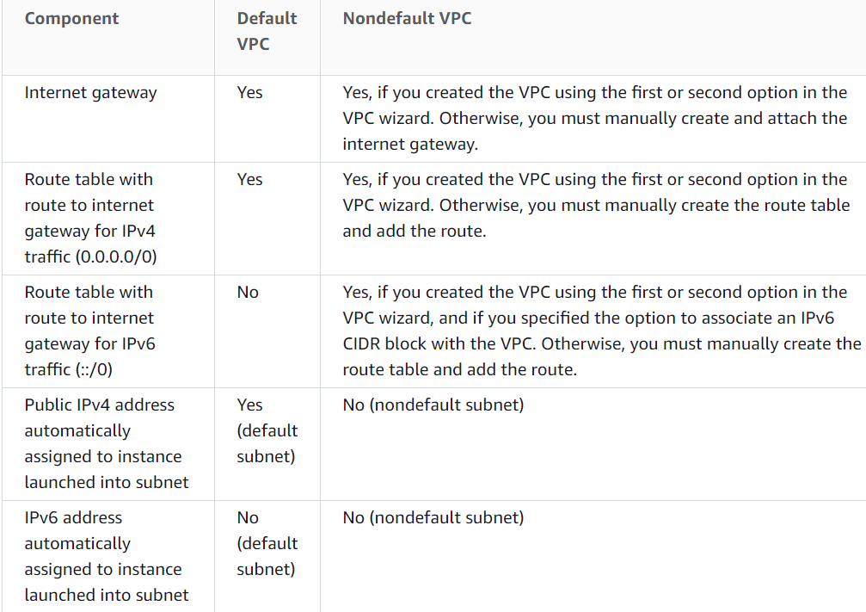

**Creation of IGW and attaching to VPC:**

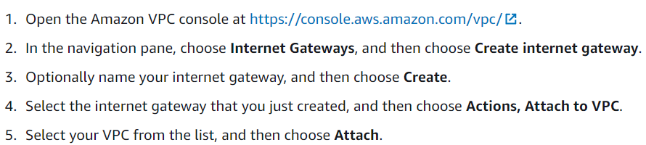

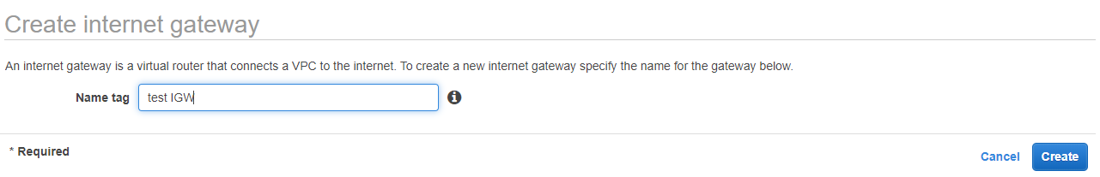

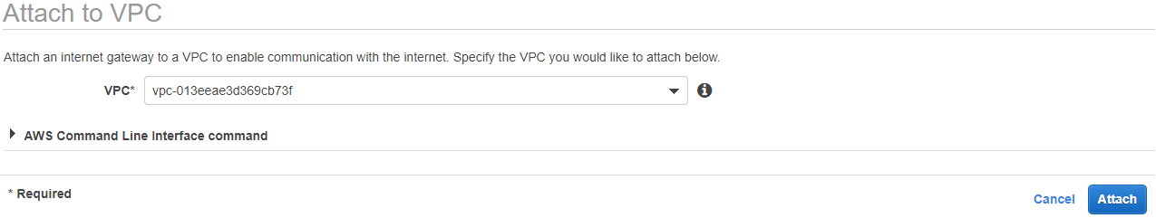

* Create an IGW by giving a tag name and attach it to the VPC. Then only the instances inside the VPC can get the internet access
* Even after attaching the IGW, subnet doesn’t know how to go and connect the internet. We need to create routing tables for that. This one also gets created automatically with wizard

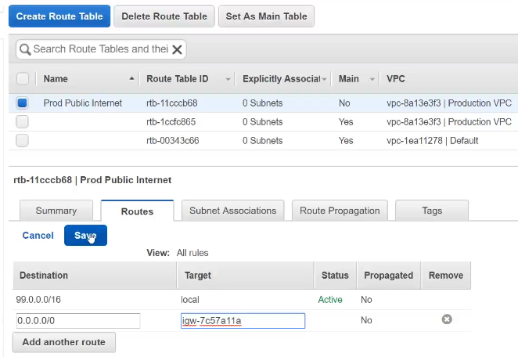

* After creating the route table with VPC. By default, it will have the local destination which is the destination of whole VPC range of IPs.
* We can’t delete the local target IP range
* If we want to allow the internet access. We need to add the destination IP as above and we need to give IGW as target and save it

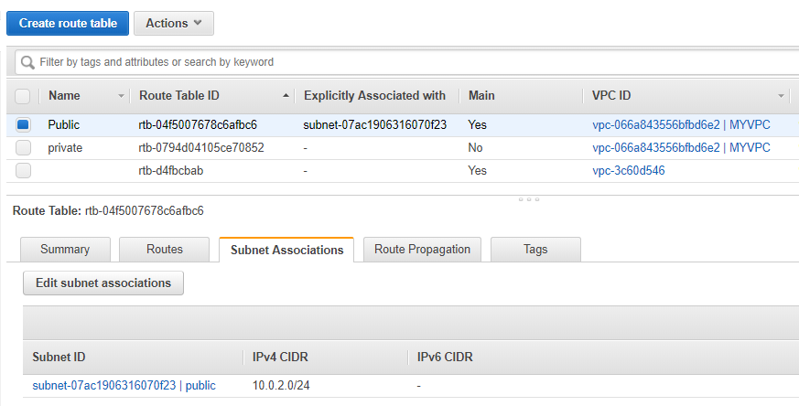

There will be default route table for the VPC. If we want, we can create route tables manually for public and private subnets as above

* Also create route table for private subnet which is used to route internally

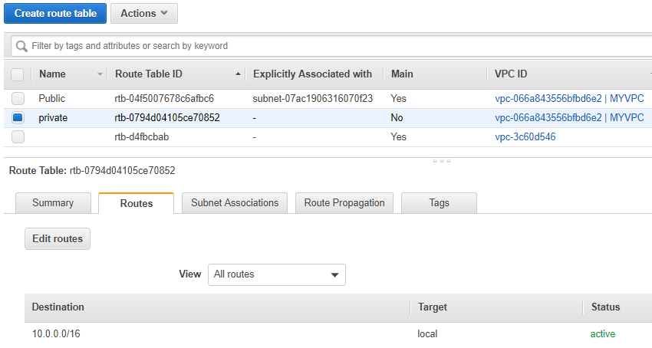

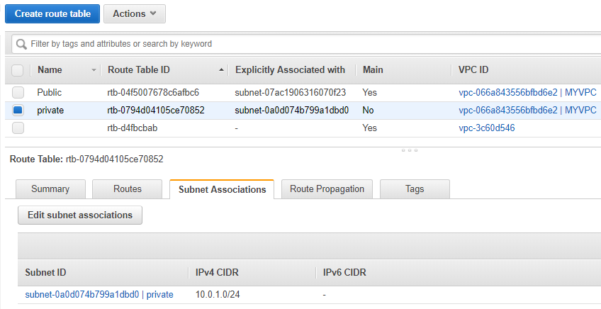

* And we need to subnet association also for the subnets which need the routes that configured earlier
* If we don’t associate the subnet here. Then the instances under that subnet won’t get internet access
* **We have to associate another subnet to route to VPC if it is in another for accessing internally**
* **We can have only one IGW per VPC**

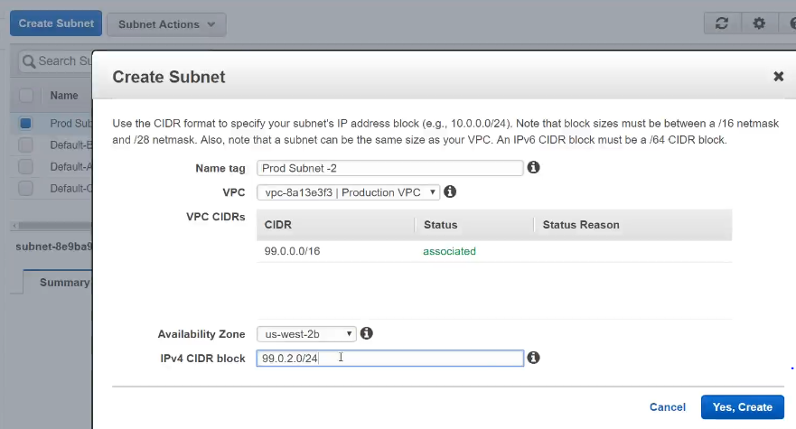

* Create one more subnet inside the VPC as above which we don’t want internet access
* Now create an instance by using the subnet which we created

**Detach internet gateway:**

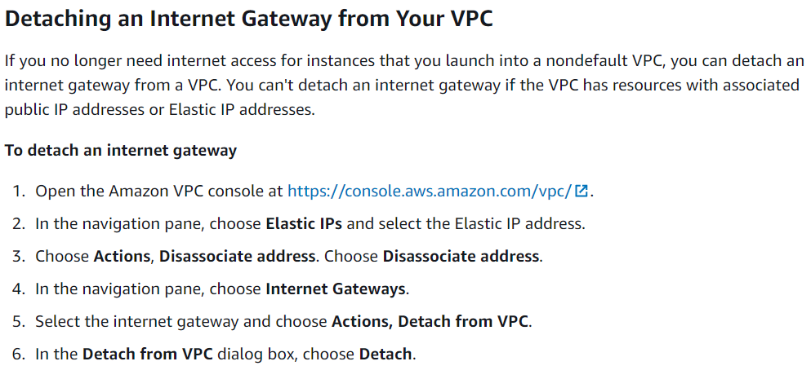

* We can’t detach the gateway if any public IP or elastic IP using it
* We can stop the instances that are running with internet gateway VPC using public or elastic IP and detach it

**Deleting internet gateway:**

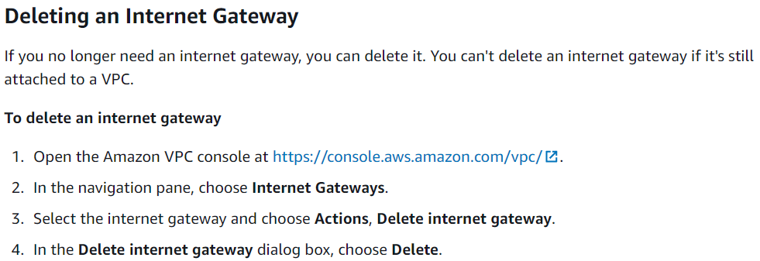

* We can’t delete the internet gateway without detaching it